**TASK 11**

**Question 1: Access modifier:**

**Answer:** Access modifier allows to set the scope or accessibility of data member be it a field, method, constructor.

There are 4 types of access modifier: 1. Default

2. Public

3. Private

4. Protected

**Default:**

When access is not specified then it is called as default.

The scope of default is within the package.

It uses keyword called default.

**Public:**

The particular entity is accessible throughout or outside the class, within or outside the package.

It uses keyword called public.

**Private:**

It is not accessible outside the class.

It uses keyword called private.

**Protected:**

Allows access to the entity through subclass of the class in which entity is declared.

It uses keyword called protected.

**Question 2: Difference between Exception and Error?**

**Answer: Exception:**

They are described in java.lang.Exception package.

The code of the program is accountable for exceptions.

It is possible to recover from an exception.

There are two types of exception Checked exception and unchecked exception.

In case of checked exception compiler will have the knowledge of checked exception and force to keep try and catch blocks.

**Error:**

They are described in the java.lang.Error package.

The system in which the program is running is responsible for errors.

It is not possible to recover from an error.

There is no such classification for errors, Errors are always undefined.

In case of errors compiler won’t have the knowledge of errors.

**Question 3: Differentiate between checked and unchecked exception?**

**Answer: Checked Exception:**

1. It occurs at compile time.
2. It is a sub class of exception class.
3. Example: Class not found exception, Fie not found exception.
4. Checked exceptions are propagated using throws keyword.
5. Exception class is the direct parent class for the checked exception subclass.

**Unchecked Exception:**

1. It occurs at run time.
2. Since it happens in run time, it is not a part of exception.
3. Example: Null Pointer exception, Array out of bound exception
4. Unchecked exceptions are automatically propagated.
5. Run time exception class is the direct parent class for the unchecked exception subclass.

**Question 4: Output for division of two numbers and throwing exception.**

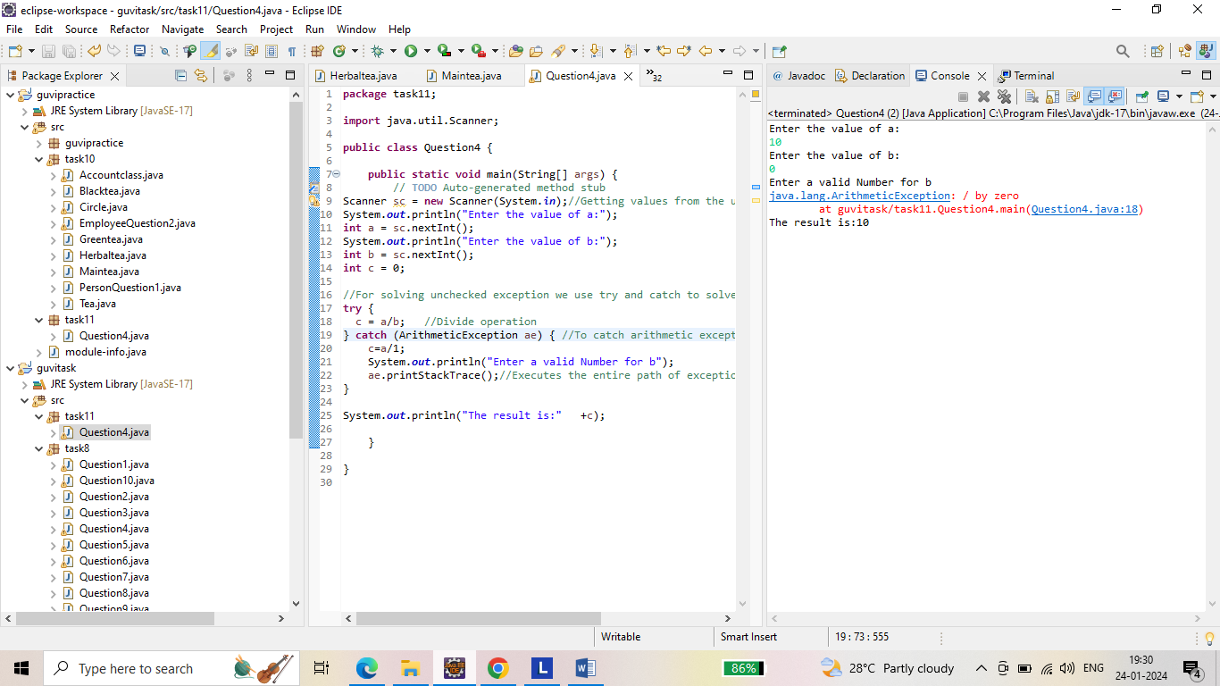

**Question 5: Output for ArrayIndexOutOfBoundException and StringIndexOutOfBoundException.**

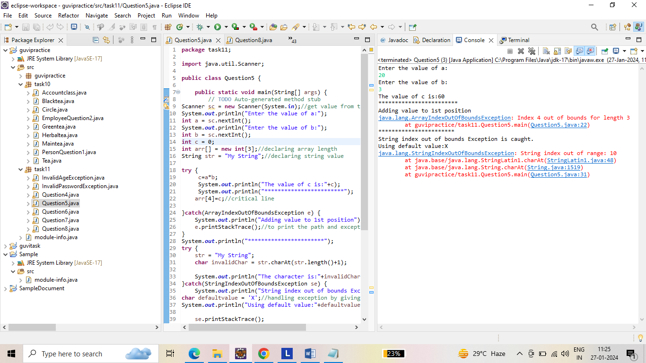

**Question 6: Output for Checking Invalid password and throw exception with error message.**

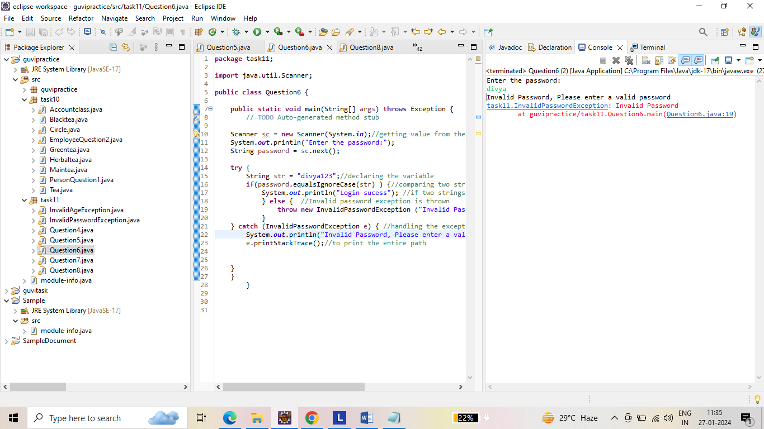

**Question 7: Output for checking if the age is less than 18 throw an InvalidAgeException.**

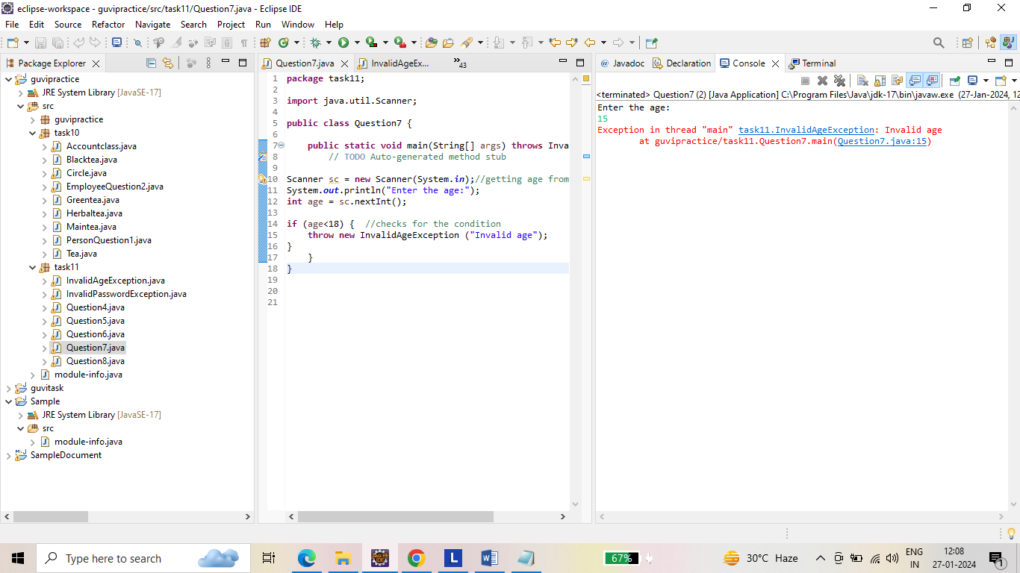

**Question 8: Output for** **FileNotFoundException.**

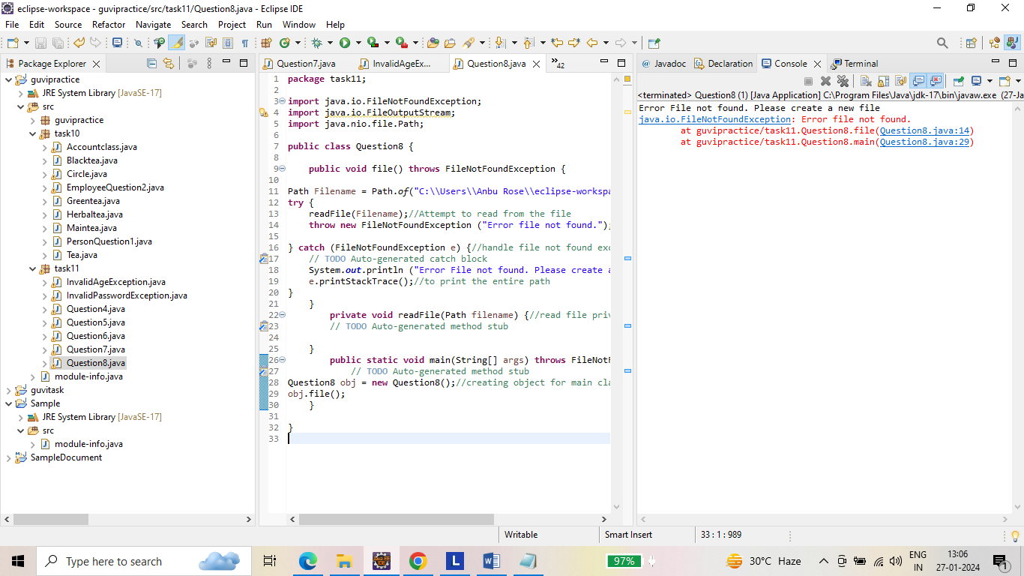

------------- THANK YOU ------------